**LAB 1**

**Q1) Now create tables and insert at least 5 campuses in Campus_degree, 5 student in**

**each campus and 10 course marks for each student.**

**CREATE TABLE QUERY:**

CREATE TABLE Campus_degree (

Campus_id NUMBER PRIMARY KEY,

Campus VARCHAR2(50),

Degree VARCHAR2(50)

);

**INSERTION IN TABLE QUERY:**

INSERT INTO Campus_degree (Campus_id, Campus, Degree) VALUES (1, &#39;Karachi Campus&#39;,

&#39;Computer Science&#39;);

INSERT INTO Campus_degree (Campus_id, Campus, Degree) VALUES (2, &#39;Lahore Campus&#39;,

&#39;Electrical Engineering&#39;);

INSERT INTO Campus_degree (Campus_id, Campus, Degree) VALUES (3, &#39;Islamabad

Campus&#39;, &#39;Business

Administration&#39;);

INSERT INTO Campus_degree (Campus_id, Campus, Degree) VALUES (4,

&#39;Faisalabad Campus&#39;, &#39;Mechanical

Engineering&#39;);

CREATE TABLE Student_Performance ( Sid

NUMBER,

Course_code VARCHAR2(10),

Marks NUMBER,

PRIMARY KEY (Sid, Course_code),

FOREIGN KEY (Sid) REFERENCES Campus_degree (Campus_id)

);

CREATE TABLE Student_Campus ( Sid

NUMBER PRIMARY KEY,

Campus_id NUMBER,

FOREIGN KEY (Sid) REFERENCES Campus_degree (Campus_id),

FOREIGN KEY (Campus_id) REFERENCES Campus_degree (Campus_id) );

INSERT INTO Student_Campus (Sid, Campus_id) VALUES (1, 1);

INSERT INTO Student_Campus (Sid, Campus_id) VALUES (2, 2);

INSERT INTO Student_Campus (Sid, Campus_id) VALUES (3, 3);

INSERT INTO Student_Campus (Sid, Campus_id) VALUES (4, 4);

INSERT INTO Student_Campus (Sid, Campus_id) VALUES (5, 5);

INSERT INTO Student_Performance (Sid, Course_code, Marks) VALUES (1, &#39;CS101&#39;, 90);

INSERT INTO Student_Performance (Sid, Course_code, Marks) VALUES (2, &#39;EE101&#39;, 85);

INSERT INTO Student_Performance (Sid, Course_code, Marks) VALUES (3, &#39;BA201&#39;, 78);

INSERT INTO Student_Performance (Sid, Course_code, Marks) VALUES (4, &#39;ME101&#39;, 92);

INSERT INTO Student_Performance (Sid, Course_code, Marks) VALUES (5, &#39;MED101&#39;, 88);

**Q2) Perform equijoin, outer join on above table**

**EQUIJOIN**

SELECT Student_Campus.Sid, Campus_degree.Campus, Campus_degree.Degree FROM

Student_Campus

JOIN Campus_degree ON Student_Campus.Campus_id =

Campus_degree.Campus_id;

**LEFT JOIN**

SELECT Student_Campus.Sid, Campus_degree.Campus, Campus_degree.Degree FROM

Student_Campus

LEFT JOIN Campus_degree ON Student_Campus.Campus_id =

Campus_degree.Campus_id;

**RIGHT OUTER JOIN**

SELECT Student_Campus.Sid, Campus_degree.Campus, Campus_degree.Degree FROM

Student_Campus

RIGHT JOIN Campus_degree ON Student_Campus.Campus_id =

Campus_degree.Campus_id;

**Q3) Perform group by clause using Student_Performance**

**QUERY:**

SELECT Course_code, AVG(Marks) AS AverageMarks

FROM Student_Performance

GROUP BY Course_code;

**LAB 2**

**Q) Create sql query of all above denormalization techniques by using HR or**

**student_performance schema.**

**Denormalization Techniques using student_performance Schema:**

CREATE TABLE Denormalized_Student_Performance AS

SELECT SP.Sid, SP.Course_code, SP.Marks, SC.Campus_id, CD.Campus, CD.Degree

FROM Student_Performance SP

JOIN Student_Campus SC ON SP.Sid = SC.Sid

JOIN Campus_degree CD ON SC.Campus_id = CD.Campus_id;

**COLLAPSING:**

CREATE TABLE Denormalized_Employee_Manager AS

SELECT e.employee_id, e.first_name, e.last_name, e.salary * 12 AS annual_salary,

m.employee_id AS manager_id, m.first_name AS manager_first_name, m.last_name AS

manager_last_name FROM employees e

LEFT JOIN employees m ON e.manager_id = m.employee_id;

**HORIZONTAL SPLITTING:**

CREATE TABLE Employees_Hired_Before AS SELECT * FROM employees

WHERE hire_date &lt; TO_DATE(&#39;01-JAN-2000&#39;, &#39;DD-MON-YYYY&#39;);

VERTICAL SPLITTQUERY ING:

CREATE TABLE Employee_Basic_Info AS

SELECT employee_id, first_name, last_name, email, hire_date FROM

employees;

**LAB 3**

**Q 1) Create a query to display all data in sal_fact table.**

SELECT * from AV.&quot;SALES_FACT&quot;;

**Q 2) Write a query to display quarterly sales of departments in different region.**

SELECT

MONTH_ID,

CATEGORY_ID,

SUBSTR(MONTH_ID, 1, 3) AS Quarter,

STATE_PROVINCE_ID,

SUM(SALES) AS Quarterly_Sales

FROM

AV.SALES_FACT

GROUP BY

MONTH_ID,

CATEGORY_ID,

SUBSTR(MONTH_ID, 1, 3),

STATE_PROVINCE_ID;

**Q 3) Write a query to display quarterly sales of country**

SELECT

MONTH_ID,

SUBSTR(MONTH_ID, 1, 3) AS Quarter,

SUBSTR(STATE_PROVINCE_ID, INSTR(STATE_PROVINCE_ID, &#39;_&#39;) + 1) AS Country,

SUM(SALES) AS Quarterly_Sales

FROM

AV.SALES_FACT

GROUP BY

MONTH_ID,

SUBSTR(MONTH_ID, 1, 3),

SUBSTR(STATE_PROVINCE_ID, INSTR(STATE_PROVINCE_ID, &#39;_&#39;) + 1);

**Q 4) Write a query to display yearly unit sold in different region**

SELECT

SUBSTR(MONTH_ID, -2) AS Year,

STATE_PROVINCE_ID,

SUM(UNITS) AS Yearly_Units_Sold

FROM AV.SALES_FACT

GROUP BY

SUBSTR(MONTH_ID, -2),

STATE_PROVINCE_ID;

**Q 5) Write a query to display monthly sales and unit sold in different region.**

SELECT

MONTH_ID,

STATE_PROVINCE_ID,

SUM(SALES) AS Monthly_Sales,

SUM(UNITS) AS Monthly_Units_Sold

FROM AV.SALES_FACT

GROUP BY MONTH_ID,

STATE_PROVINCE_ID;

**Q 6) Write a query to display seasonally sales in different providence**

SELECT

Season,

STATE_PROVINCE_ID,

SUM(SALES) AS Seasonal_Sales

FROM (

SELECT

CASE

WHEN MONTH_ID IN (&#39;Dec&#39;, &#39;Jan&#39;, &#39;Feb&#39;) THEN &#39;Winter&#39;

WHEN MONTH_ID IN (&#39;Mar&#39;, &#39;Apr&#39;, &#39;May&#39;) THEN &#39;Spring&#39;

WHEN MONTH_ID IN (&#39;Jun&#39;, &#39;Jul&#39;, &#39;Aug&#39;) THEN &#39;Summer&#39;

WHEN MONTH_ID IN (&#39;Sep&#39;, &#39;Oct&#39;, &#39;Nov&#39;) THEN &#39;Autumn&#39;

END AS Season,

STATE_PROVINCE_ID,

SALES

FROM

AV.SALES_FACT

) AS SeasonalData

GROUP BY

Season,

STATE_PROVINCE_ID;

**LAB 4 - ERD Plus and Star Schema**

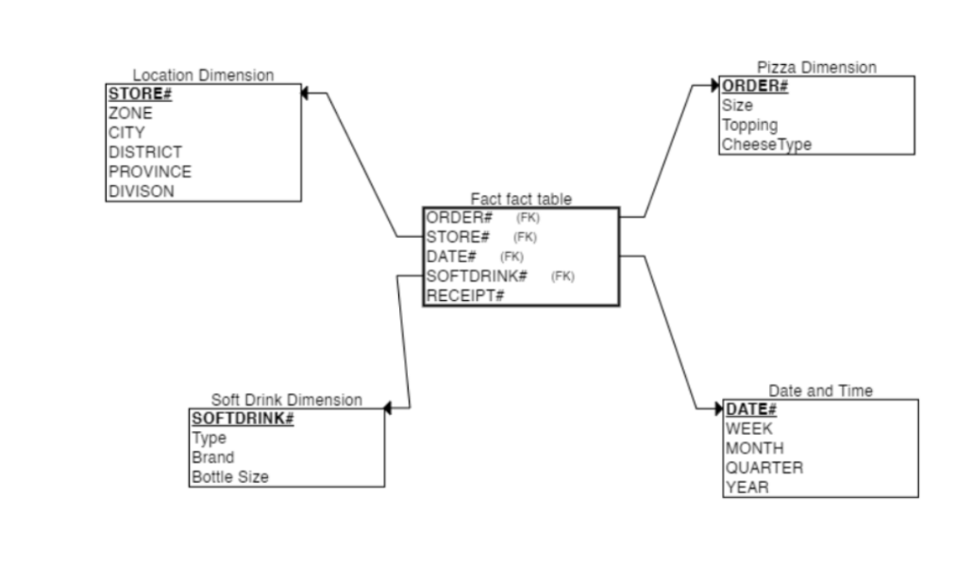

**Generated Query**

CREATE TABLE Location_Dimension

(

STORE# INT NOT NULL,

CITY CHAR NOT NULL,

DISTRICT CHAR NOT NULL,

PROVINCE CHAR NOT NULL,

DIVISON INT NOT NULL,

PRIMARY KEY (STORE#)

);

CREATE TABLE Pizza_Dimension

(

ORDER# INT NOT NULL,

Size CHAR NOT NULL,

Topping CHAR NOT NULL,

CheeseType CHAR NOT NULL,

PRIMARY KEY (ORDER#)

);

CREATE TABLE Date_and_Time

(

DATE# DATE NOT NULL,

WEEK CHAR NOT NULL,

MONTH CHAR NOT NULL,

QUARTER CHAR NOT NULL,

YEAR CHAR NOT NULL,

PRIMARY KEY (DATE#)

);

CREATE TABLE Soft_Drink_Dimension

(

SOFTDRINK# INT NOT NULL,

Type CHAR NOT NULL,

Brand CHAR NOT NULL,

Bottle_Size CHAR NOT NULL,

PRIMARY KEY (SOFTDRINK#)

);

CREATE TABLE Fact

(

RECEIPT# INT NOT NULL,

ORDER# INT NOT NULL,

STORE# INT NOT NULL,

DATE# DATE NOT NULL,

SOFTDRINK# INT NOT NULL,

FOREIGN KEY (STORE#) REFERENCES Location_Dimension(STORE#),

FOREIGN KEY (DATE#) REFERENCES Date_and_Time(DATE#),

FOREIGN KEY (SOFTDRINK#) REFERENCES Soft_Drink_Dimension(SOFTDRINK#)

);

**Schema**

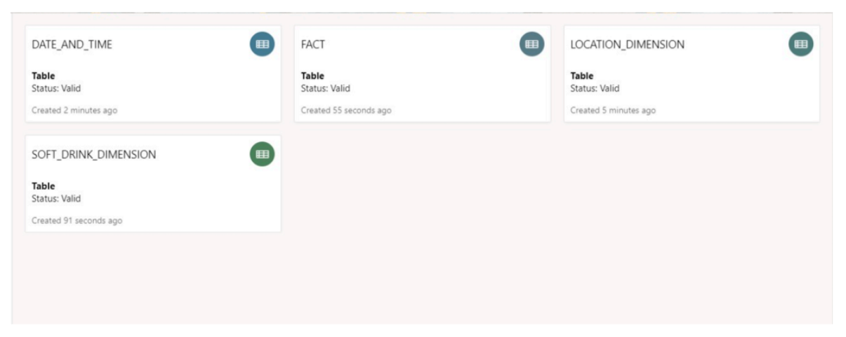

**Practical No 5**

**Q 1. Create a query to perform roll up operation using av.sales_fact table.**

**(Note:-examine all data)**

A.

SELECT

month_id,

category_id,

state_province_id,

SUM(sales) AS total_sales,

SUM(units) AS total_units

FROM

av.sales_fact

GROUP BY

ROLLUP (month_id, category_id, state_province_id);

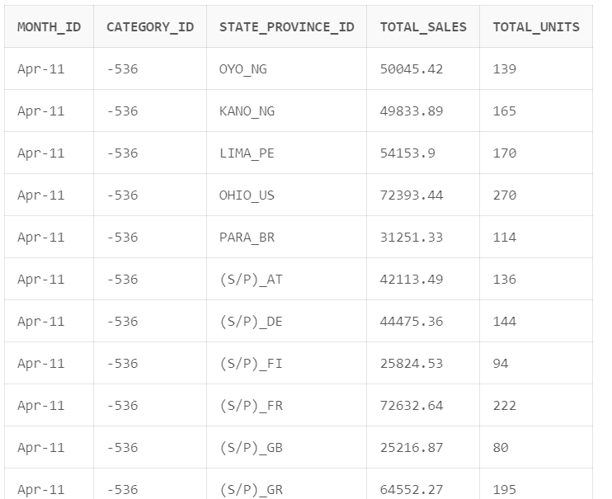

**Q 2. Create a query to perform cube operation using av.sales_fact table. (Note: Also examine the data)**

A.

SELECT

month_id,

category_id,

state_province_id,

SUM(sales) AS total_sales,

SUM(units) AS total_units

FROM

av.sales_fact

GROUP BY

CUBE(month_id, category_id, state_province_id);

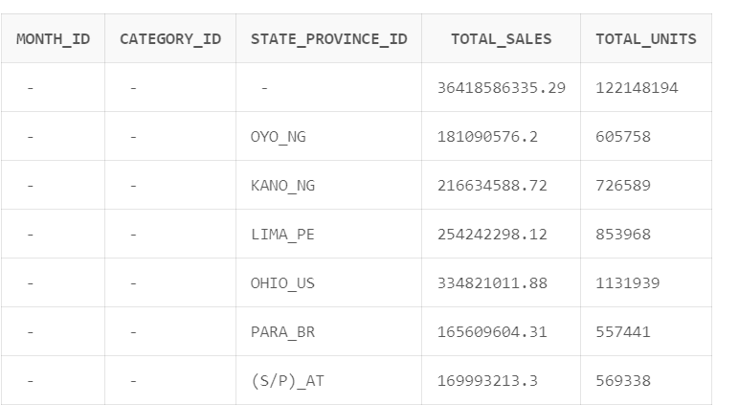

**Q 3. Why we use roll up, cube and pivot function and what are the differences between them.**

A. Roll-up, cube, and pivot functions in SQL serve distinct purposes for data summarization. Roll-up is utilized to generate subtotals and a grand total for a specified set of columns, providing a hierarchical view. Cube, similar to roll-up, extends this by calculating subtotals and a grand total for all possible combinations of specified columns, offering a multidimensional perspective. Pivot, however, is employed to transform row data into a columnar format, enhancing readability, and is often used with aggregate functions for summarization. While roll-up and cube focus on hierarchical and dimensional analysis, providing subtotals at various levels, pivot primarily deals with restructuring data for better presentation. Each function is valuable in specific contexts, catering to diverse analytical needs.

**Q 4. Perform pivot operations uing AV schema.**

A.

SELECT

month_id,

SUM(units) AS total_units

FROM

av.sales_fact

GROUP BY month_id

ORDER BY month_id;

|  |  |
| --- | --- |
| MONTH_ID | TOTAL_UNITS |
| Apr-11 | 2002303 |
| Apr-12 | 1998655 |
| Apr-13 | 2002657 |
| Apr-14 | 2003542 |
| Apr-15 | 2001030 |
| Aug-11 | 2042569 |
| Aug-12 | 2043836 |
| Aug-13 | 2043454 |
| Aug-14 | 2043335 |
| Aug-15 | 2043437 |
| Dec-11 | 2100209 |
| Dec-12 | 2100892 |
| Dec-13 | 2101709 |
| Dec-14 | 2101171 |
| Dec-15 | 2101992 |
| Feb-11 | 1866893 |
| Feb-12 | 1804964 |
| Feb-13 | 1804810 |
| Feb-14 | 1803959 |
| Feb-15 | 1869027 |
| Jan-11 | 1993656 |
| Jan-12 | 1990711 |
| Jan-13 | 1990777 |
| Jan-14 | 1991853 |
| Jan-15 | 1993658 |
| Jul-11 | 2077429 |
| Jul-12 | 2078935 |
| Jul-13 | 2080226 |
| Jul-14 | 2076820 |
| Jul-15 | 2078469 |
| Jun-11 | 2062078 |
| Jun-12 | 2064009 |
| Jun-13 | 2062598 |
| Jun-14 | 2061538 |
| Jun-15 | 2064798 |
| Mar-11 | 2031777 |
| Mar-12 | 2030877 |
| Mar-13 | 2030850 |
| Mar-14 | 2032628 |
| Mar-15 | 2032913 |
| May-11 | 2105096 |
| May-12 | 2105387 |
| May-13 | 2107216 |
| May-14 | 2106202 |
| May-15 | 2106537 |
| Nov-11 | 2044448 |
| Nov-12 | 2046881 |
| Nov-13 | 2044461 |
| Nov-14 | 2045638 |
| Nov-15 | 2046639 |

**Q 5. Create pivot operation using SH schema.**

A.

SELECT

prod_id,

SUM(quantity_sold) AS total_items_sold

FROM

sh.profits

GROUP BY prod_id

ORDER BY prod_id;

|  |  |
| --- | --- |
| PROD_ID | TOTAL_ITEMS_SOLD |
| 13 | 6002 |
| 14 | 6010 |
| 15 | 5764 |
| 16 | 6928 |
| 17 | 6160 |
| 18 | 9589 |
| 19 | 10430 |
| 20 | 10903 |
| 21 | 4913 |
| 22 | 3441 |
| 23 | 19642 |
| 24 | 20948 |
| 25 | 19557 |
| 26 | 15651 |
| 27 | 11979 |
| 28 | 16796 |
| 29 | 7197 |
| 30 | 28979 |
| 31 | 23108 |
| 32 | 11253 |

**Q 6. Create a view using cube operation.**

A.

CREATE VIEW cube_view AS

SELECT

month_id,

category_id,

SUM(units) AS total_units

FROM

av.sales_fact

GROUP BY

CUBE(month_id, category_id);

**Practical No: - 6**

*Theory: refers to what has been seen in class (using HR schema).*

**Q1. Create a materialized view that store last name and salary of employees earning more than $12,000.**

A:-

CREATE MATERIALIZED VIEW mv_high_salary_employees

BUILD IMMEDIATE

REFRESH COMPLETE

AS

SELECT last_name, salary

FROM hr.employees

WHERE salary > 12000;

**Q2. Create a materialized view called EMPLOYEES_VU on the employee numbers, employee names, and department numbers from the EMPLOYEES table**

A:-

CREATE MATERIALIZED VIEW EMPLOYEES_VU

BUILD IMMEDIATE

REFRESH COMPLETE

AS

SELECT employee_id, first_name || ' ' || last_name AS employee_name, department_id

FROM hr.employees;

**Q3. Insert one employee in to employees table than Display the contents of the EMPLOYEES_VU view also what is the difference between employees table and materialized view.**

A:-

-- Inserting a new employee

INSERT INTO hr.employees (employee_id, first_name, last_name, department_id)

VALUES (1001, 'John', 'Doe', 30);

-- Displaying contents of the materialized view

SELECT * FROM EMPLOYEES_VU;

A table is a permanent storage structure that always reflects the latest data, a materialized view is a precomputed, stored result set that can be used to improve query performance at the cost of potentially having slightly stale data.

**Q4.Write a query to manually refresh EMPLOYEES_VU.**

A:-

EXEC DBMS_MVIEW.REFRESH('EMPLOYEES_VU', 'C');

Q5.Create a materialize view that store the number of people with the same job.

A:-

CREATE MATERIALIZED VIEW job_count_mv

BUILD IMMEDIATE

REFRESH COMPLETE

AS

SELECT job_id, COUNT(*) AS num_people

FROM hr.employees

GROUP BY job_id;

**Q5.Modify Lab 4 3.sql create a materialized view that Oracle refresh automatically.**

A:-

CREATE MATERIALIZED VIEW job_count_mv

BUILD IMMEDIATE

REFRESH FAST ON COMMIT

AS

SELECT job_id, COUNT(*) AS num_people

FROM hr.employees

GROUP BY job_id;

**Q6.Create a materialize view that that store the difference between the highest a nd lowest salaries. Label the column DIFFERENCE.**

A:-

CREATE MATERIALIZED VIEW salary_difference_mv

BUILD IMMEDIATE

REFRESH COMPLETE

AS

SELECT (MAX(salary) - MIN(salary)) AS DIFFERENCE

FROM hr.employees;

**LAB 7-8**

Theory refers to what has been discussed in class (using Av schema).

**Q 1. Create a query to display geography, product and time dimension data.**

 (Note:-examine all data)

A.

SELECT * FROM av.geography_dim;

SELECT * FROM av.product_dim;

SELECT * FROM av.time_dim;

**Q 2. Select 40 rows form sale fact table. (Note:-examine data)**

A.

SELECT *

FROM av.sales_fact

FETCH FIRST 40 ROWS ONLY;

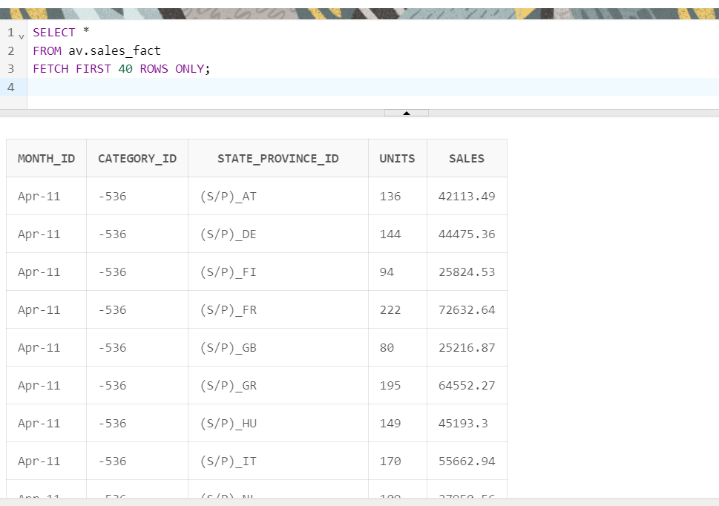

**Q 3. Why we use analytical view and what is the difference between simple analytical view and materialize analytical view.**

A.

Analytical views are used for complex analysis and reporting in a data warehouse environment. They provide a way to pre-aggregate and store results of complex queries for faster retrieval.

* **Simple Analytical View:**
  + Computed on-the-fly when queried.
  + Suitable for scenarios where real-time data is crucial.
  + May have a performance impact on large datasets.
* **Materialized Analytical View:**
  + Precomputed and stored, improving query performance.
  + Better for scenarios where query performance is a priority.
  + Requires periodic refresh to keep data up-to-date.

**Q 4. Create attribute dimension of time, geography and product dimension.**

A. **Time**:

CREATE OR REPLACE ATTRIBUTE DIMENSION time_attr_dim

USING av.time_dim

ATTRIBUTES

(year_id,

quarter_id,

month_id)

LEVEL MONTH

KEY month_id

DETERMINES (quarter_id)

LEVEL QUARTER

KEY quarter_id

DETERMINES (year_id)

LEVEL YEAR

KEY year_id;

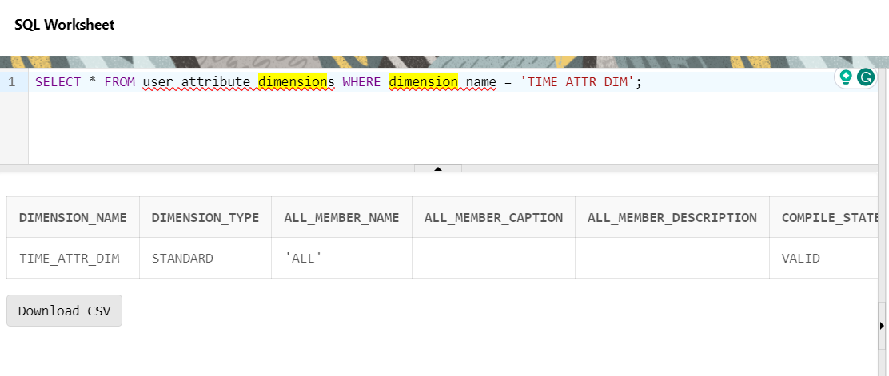

**Geography**:

CREATE OR REPLACE ATTRIBUTE DIMENSION geography_attr_dim

USING av.geography_dim

ATTRIBUTES

(region_id,

country_id,

state_province_id)

LEVEL STATE_PROVINCE

KEY state_province_id

DETERMINES (country_id)

LEVEL COUNTRY

KEY country_id

DETERMINES (region_id)

LEVEL REGION

KEY region_id;

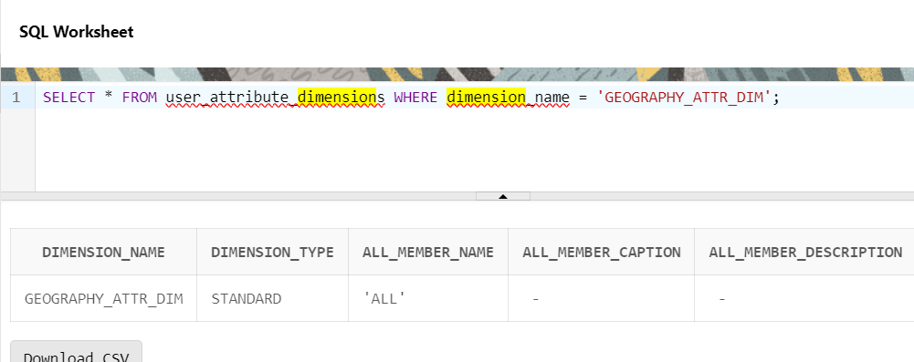

**PRODUCT**:

CREATE OR REPLACE ATTRIBUTE DIMENSION product_attr_dim

USING av.product_dim

ATTRIBUTES

(department_id,

category_id)

LEVEL CATEGORY

KEY category_id

DETERMINES (department_id)

LEVEL DEPARTMENT

KEY department_id;

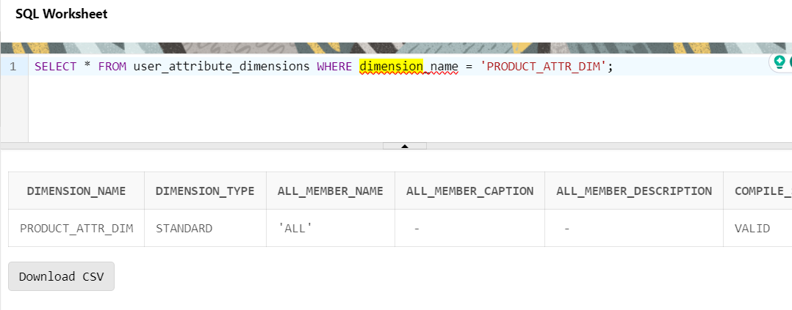

**Q 5. Create hierarchy of time, geography and product dimension.**

A.

**TIME HIERARCHY:**

CREATE OR REPLACE HIERARCHY time_hier

USING time_attr_dim

(month CHILD OF

quarter CHILD OF

year);

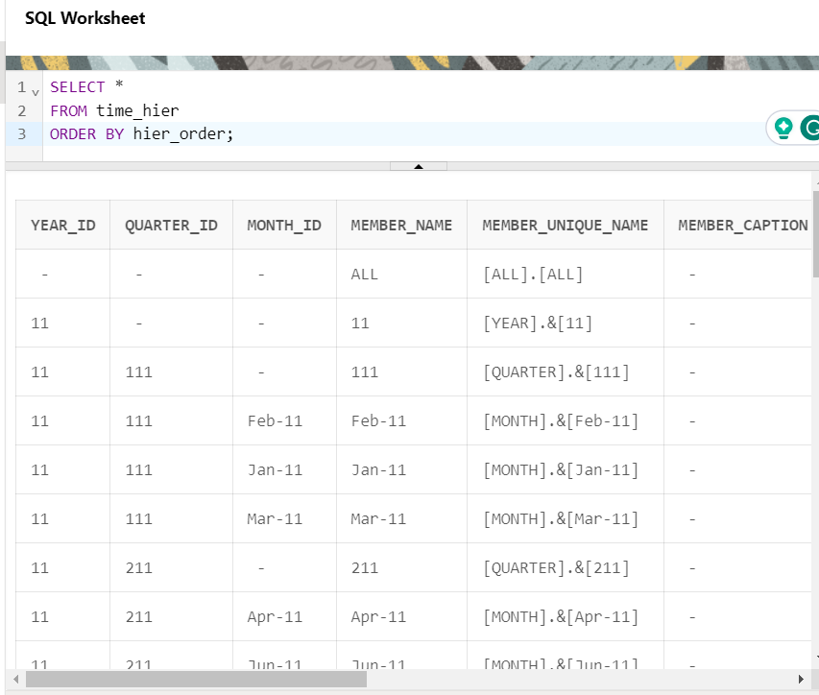

**PRODUCT HIERARCHY:**

CREATE OR REPLACE HIERARCHY product_hier

USING product_attr_dim

(category CHILD OF

department);

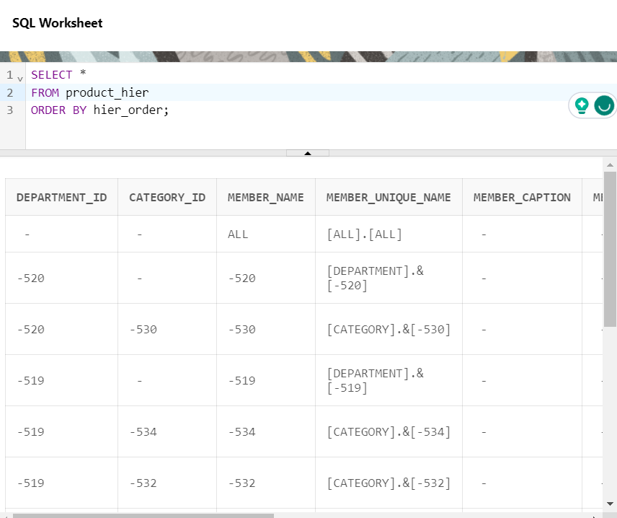

**GEOGRAPHY HIERARCHY:**

CREATE OR REPLACE HIERARCHY geography_hier

USING geography_attr_dim

(state_province CHILD OF

country CHILD OF

region);

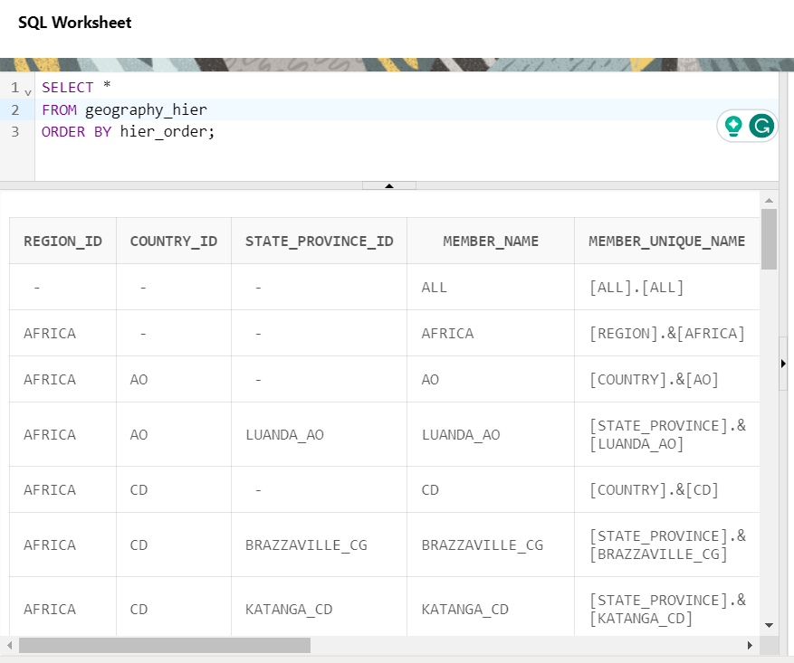

**Q 6. Using attribute dimension and hierarchy of time and geography dimension, create an analytical view which measures average and count of sale facts.Select sales at the year level.**

A.

CREATE OR REPLACE ANALYTIC VIEW sales_av

USING av.sales_fact

DIMENSION BY

(time_attr_dim

KEY month_id REFERENCES month_id

HIERARCHIES (

time_hier DEFAULT))

MEASURES

(sales FACT sales,

avg_sales FACT sales AGGREGATE BY AVG,

count_sales FACT sales AGGREGATE BY COUNT

)

DEFAULT MEASURE SALES

DEFAULT AGGREGATE BY SUM;

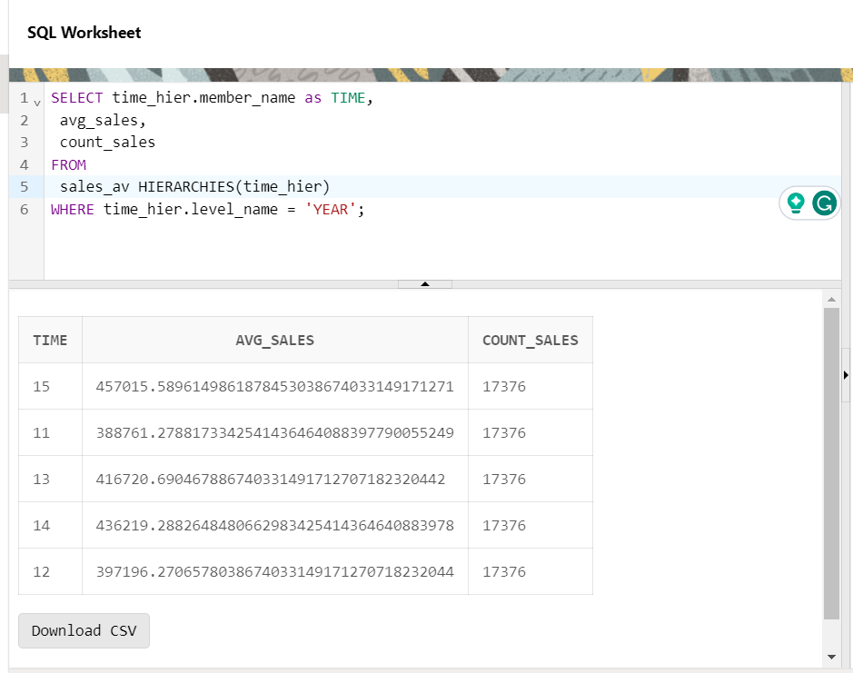

**Q 7. Using attribute dimension and hierarchy of time, geography and product dimension, create analytical view which measure max, min, count, standard deviational and variation of unit’s fact. Select sales at the REGION_IDl level and CATEGORY_ID.**

A.

CREATE OR REPLACE ANALYTIC VIEW sales_av_min_max

USING av.sales_fact

DIMENSION BY

(time_attr_dim

KEY month_id REFERENCES month_id

HIERARCHIES (

time_hier DEFAULT))

MEASURES

(sales FACT sales,

count_sales FACT sales AGGREGATE BY COUNT,

max_sales FACT sales AGGREGATE BY MAX,

min_sales FACT sales AGGREGATE BY MIN,

stddev_sales FACT sales AGGREGATE BY STDDEV,

variance_sales FACT sales AGGREGATE BY VARIANCE

)

DEFAULT MEASURE SALES

DEFAULT AGGREGATE BY SUM;

SELECT

geography_attr_dim.REGION_ID,

product_attr_dim.CATEGORY_ID,

sale_count,

avg_sale

FROM

sales_av_min_max;

**LAB 9-10**

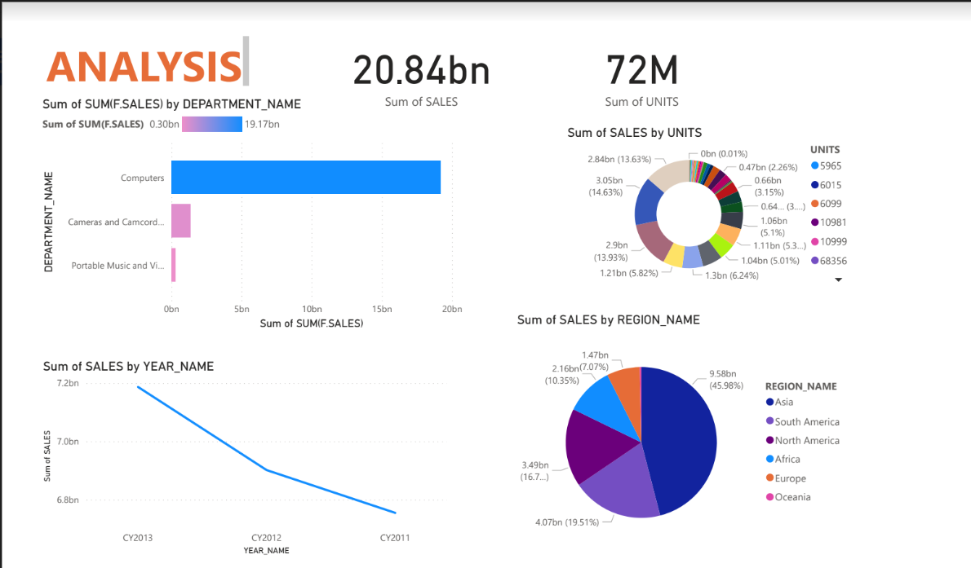

**LAB 11 & 12**

**1) Weather Integer Dataset**

**Selected Attributes:**

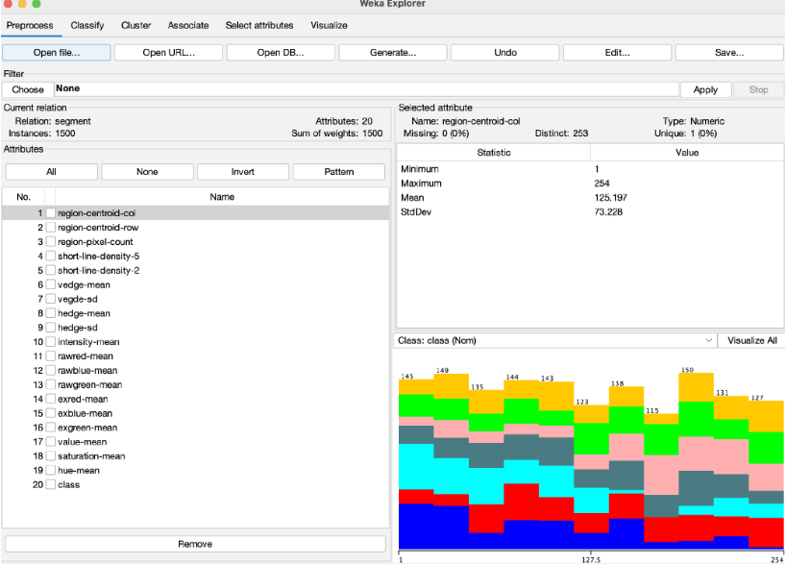

**Results Clustering ( SimpleKMeans clusterer):**

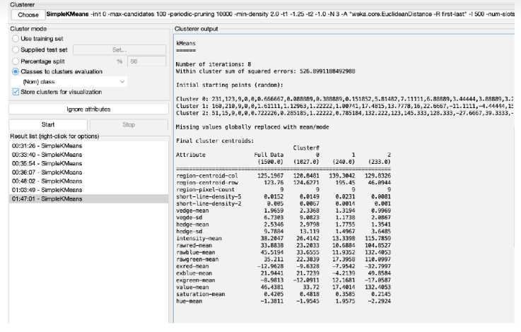

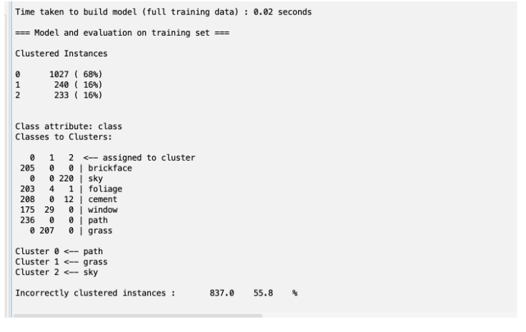

**Explanation Clustering:**

The clustering analysis was performed using the SimpleKMeans algorithm in Weka on a dataset

with 1500 instances and 20 attributes. The algorithm converged after 8 iterations, resulting in

three clusters. The within-cluster sum of squared errors was 526.90. The final cluster centroids

provide insights into the characteristics of each cluster across the attributes. The majority of

instances were assigned to Cluster 0 (68%), which represents the &#39;path&#39; class. However, the

clustering was not entirely accurate, as 55.8% of instances were incorrectly clustered. Notably,

Cluster 1 corresponds to the &#39;grass&#39; class, and Cluster 2 represents the &#39;sky&#39; class,

demonstrating the algorithm&#39;s ability to capture meaningful patterns within the data.

**2) Weather Nominal Dataset**

**Selected Attributes:**

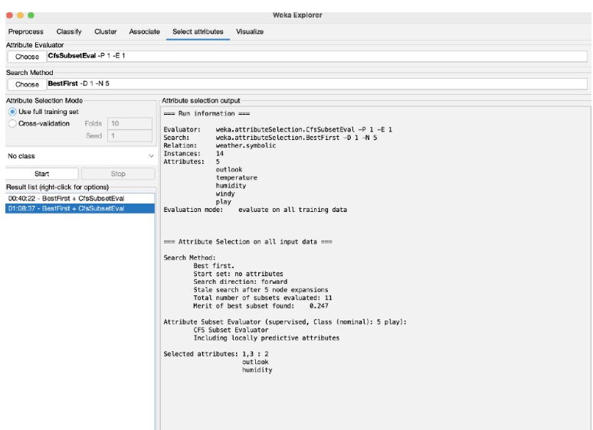

**Results Association (Apiriori):**

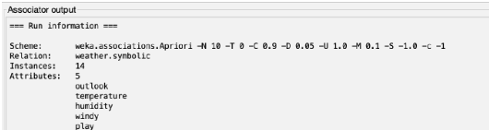

**Explanation Association:**

The Apriori association analysis on the symbolic weather dataset revealed several interesting

rules with high confidence. For instance, the rule &quot;outlook=overcast ==&gt; play=yes&quot; exhibited a

confidence of 1, indicating a strong association between overcast conditions and playing.

Similarly, rules like &quot;temperature=cool ==&gt; humidity=normal&quot; and &quot;outlook=sunny play=no ==&gt;

humidity=high&quot; demonstrated confident associations. The generated rules can provide valuable

insights into the relationships between different weather attributes and the likelihood of outdoor

activities, offering practical implications for decision-making based on weather conditions.

**3) Breast Cancer Dataset**

**Selected Attributes:**

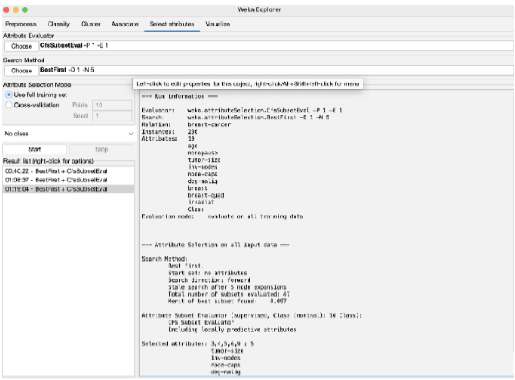

**Results Classify (Random Forest):**

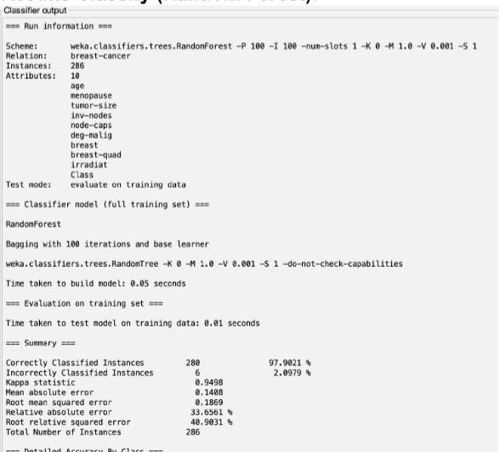

**Explanation Classifier:**

The Random Forest classification on the breast cancer dataset achieved an impressive accuracy of 97.90%. The model correctly classified instances into the recurrence event classes with high precision and recall values for both classes. The detailed accuracy by class shows that the model performed well in distinguishing between the two outcomes, with a weighted average F-measure of 0.979. The confusion matrix indicates that only a small number of instances were misclassified (6 out of 286), contributing to the model&#39;s overall reliability in predicting breast cancer recurrence based on the provided attributes.

**LAB 13**

1. **Google Trends Data:** This data represents the top 25 google searched terms on specific days.

**Query:**

From top 25, we are displaying the rank 1 term of each day.

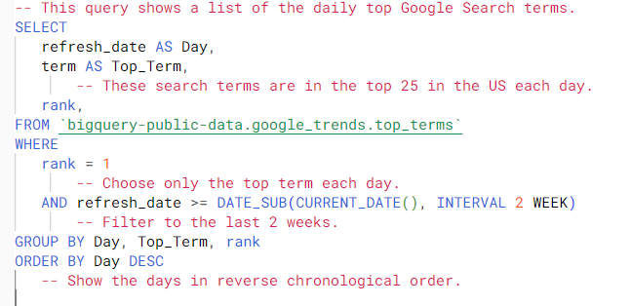

**Output**:

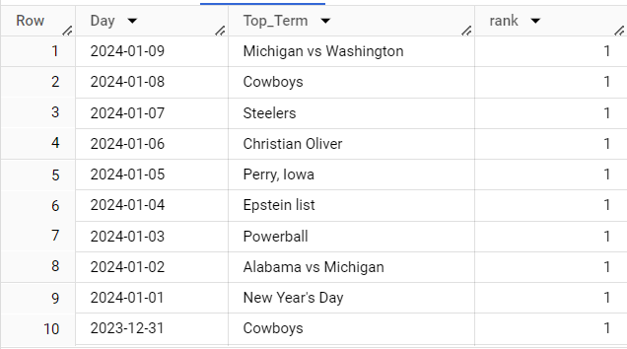

1. **Food Quality Data:**

This dataset contains the details of the consumer who eats the affected food, and the reactions (which shows that what happened to the consumer after eating that food), and the brand name of the food.

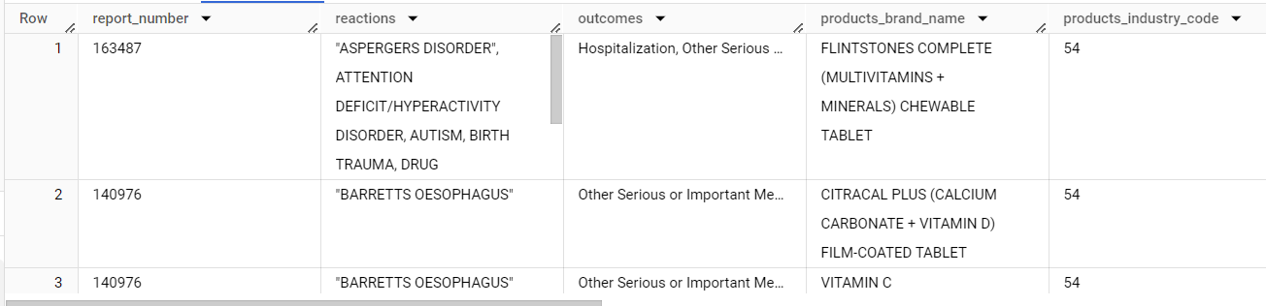

**Query**:

I have tried to show the brand name and their total no. of complaints.

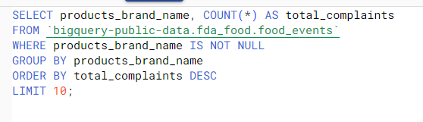

**Output**:

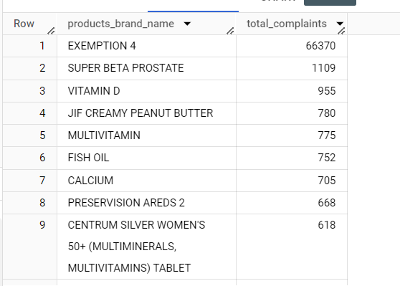

**3. Health data:** This data shows that a specific population of a certain state is physically fit, or having any disease. Like, row 751 shows that the College graduate categories of the state Michigan is physically fit.

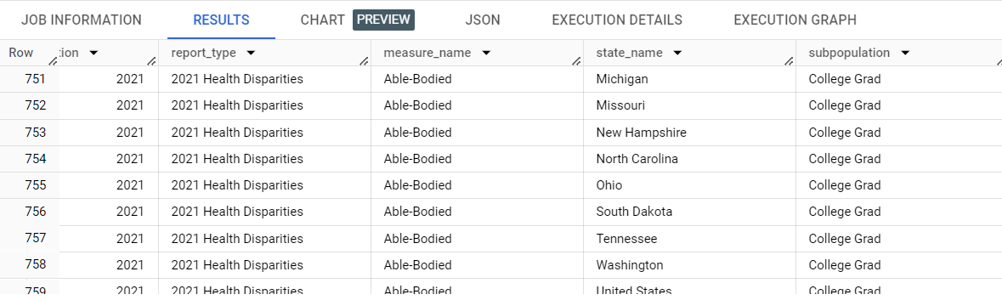

**Query**:

Now I am displaying the states with the no. of people having Asthma or physically fit.

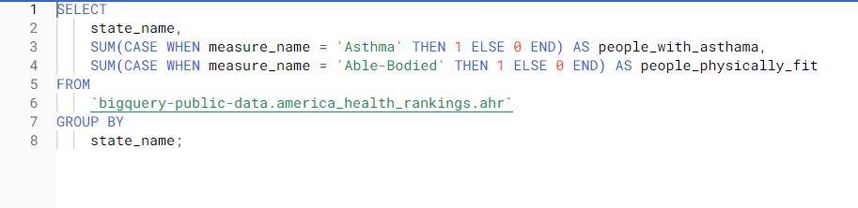

**Output**:

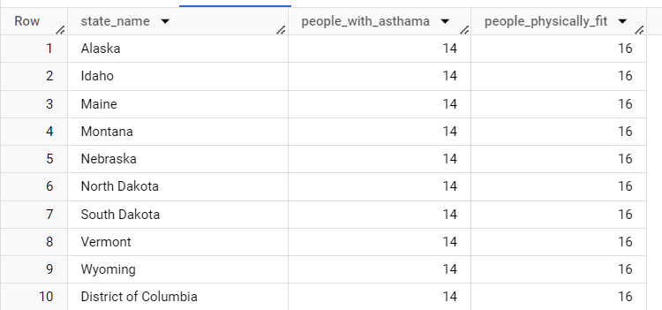

**4. Covid Data:** This data shows the daily covid cases and daily deaths and so many other information. And each country has multiple rows according to dates.

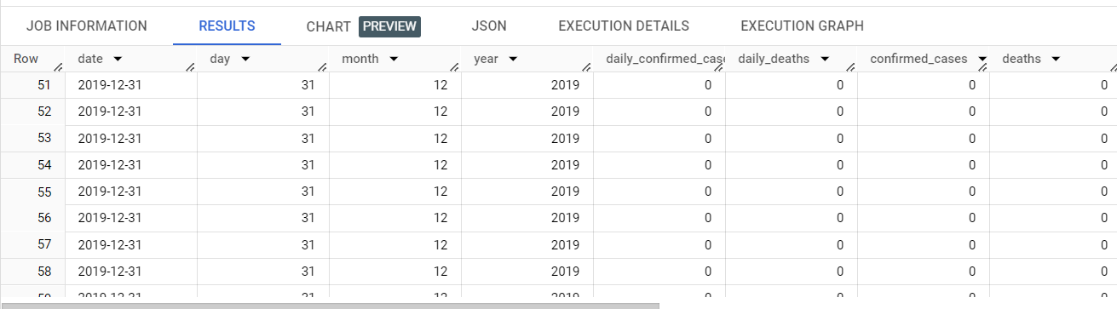

**Query**: I am displaying the overall covid cases and deaths of each country.

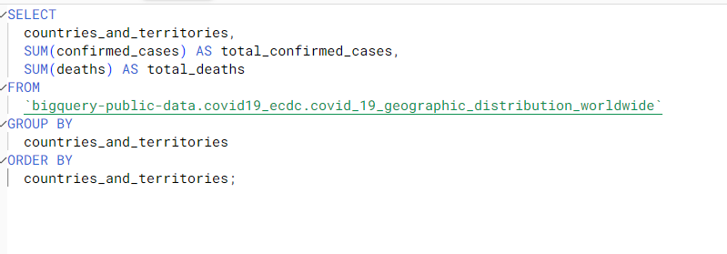

**Output**:

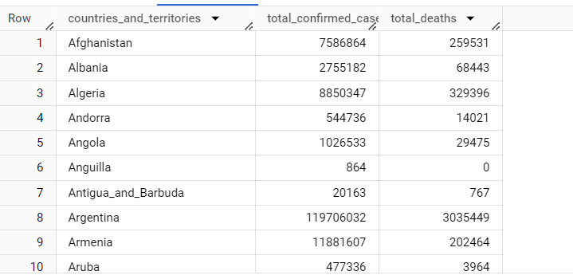

**5. London Cycle Data**: This dataset shows the hiring of London cycles, from where it is hired and also the ending stations, start and end date durations etc.

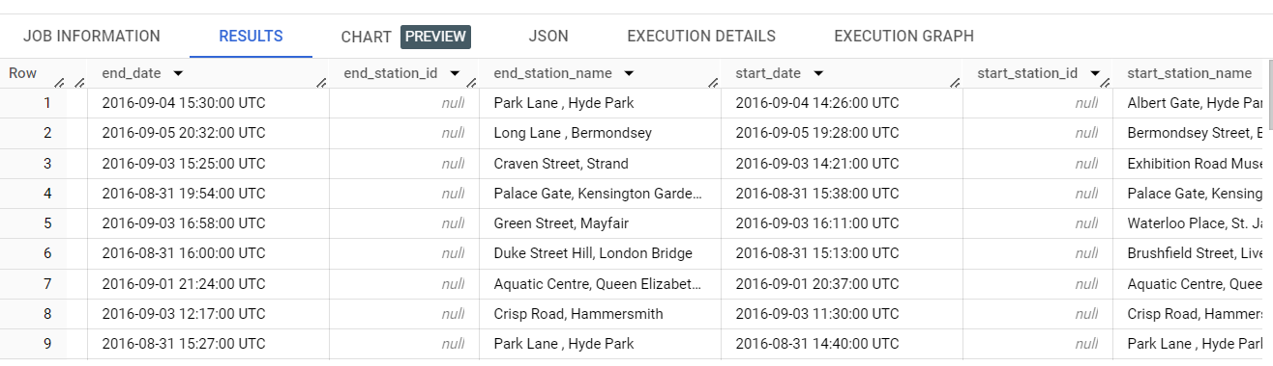

**Query**: I am displaying that from which station maximum cycle hiring occurs.

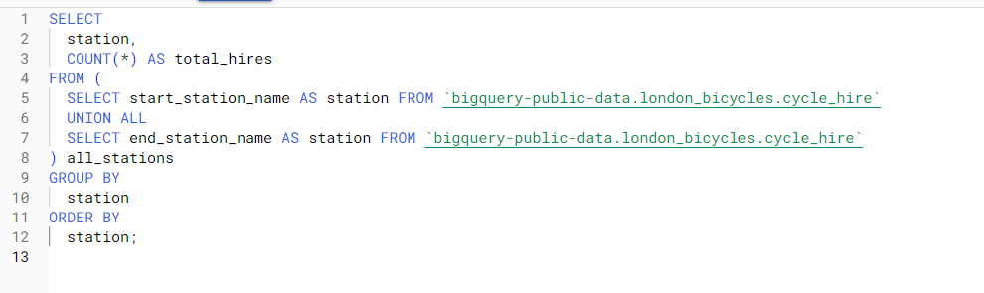

**Output:**

